What is Git and Github

**Git**: Git is a version control system that manages and keeps track of your code. This means that Git can track the state of different versions of your projects while you're developing them.

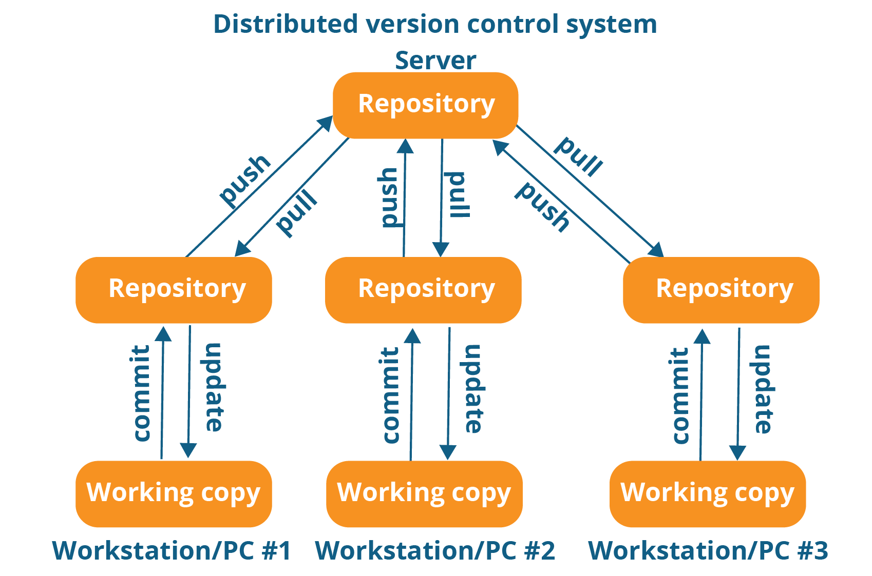

**Github**: GitHub is a web-based Git repository hosting service, It supports version controlling and collaboration and allows developers to work together on projects. It offers both distributed version control and source code management (SCM) functionality of Git.

**Difference between Git and Github**

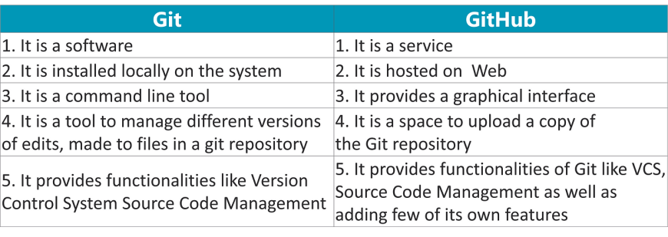

**Essential components of the GitHub are:**

Repositories

Branches

Commits

Git Push

Git Pull

Git Clone

**Repositories:** Repositories in GIT contain a collection of files of various different versions of a Project.

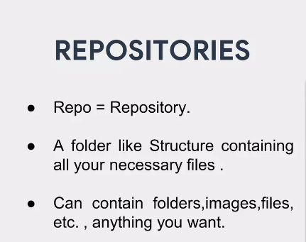

**Branches**: Branches allow you to work on different parts of a project without impacting the main branch**.**

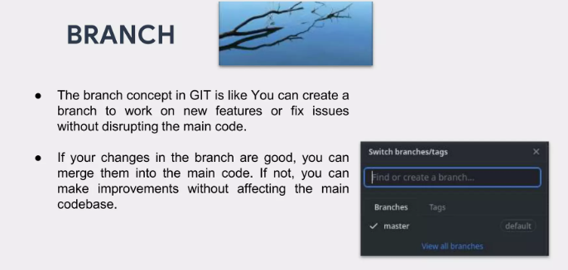

**Commits:** Commit set a message about the changes you were done. The commit also saves a revision of the code and you can revert the code to any version anytime in one click.

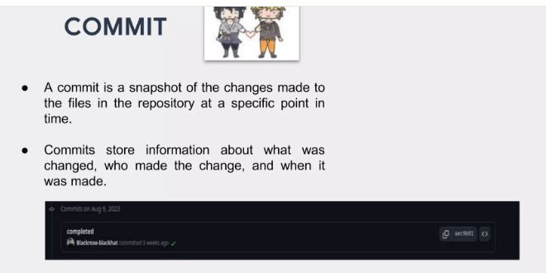

**Git Push:** Using the git push command, you can upload your files available on your local machine to the remote repository.

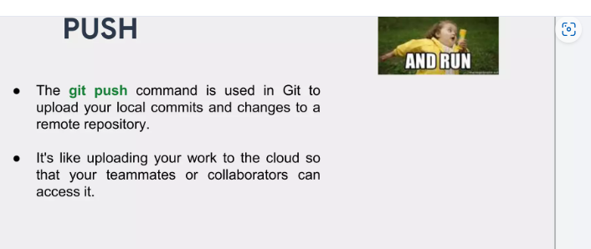

**Git Pull:** Git Pull is a command used to update the local version of a repository from a remote repository**.**

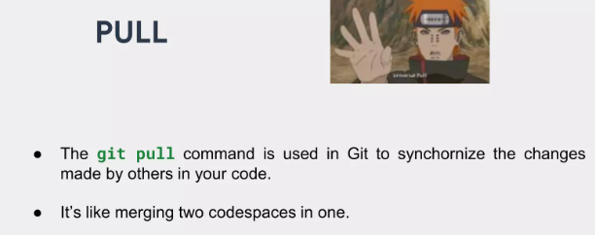

**Git Clone:** Git Clone will make a copy of the existing git repository in the local machine. This means it will download all the files and directories which are available in the repository available in the remote repository**.**

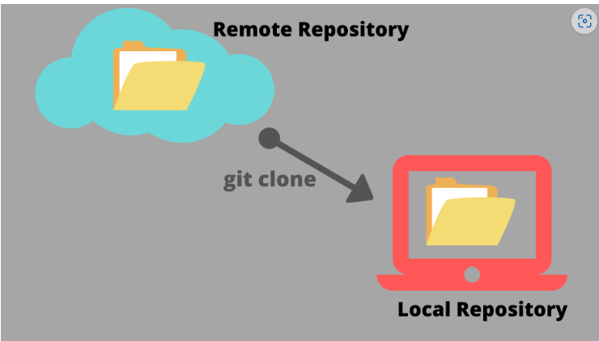

Workflow of Github**:** The GitHub flow is a workflow designed to work well with Git and GitHub.

